Borehole No. GM73
Location Nyamebekyere, Afram Plains
Latitude N 07°04.595’
Longitude W000°36.300’
Date started 20/01/2000
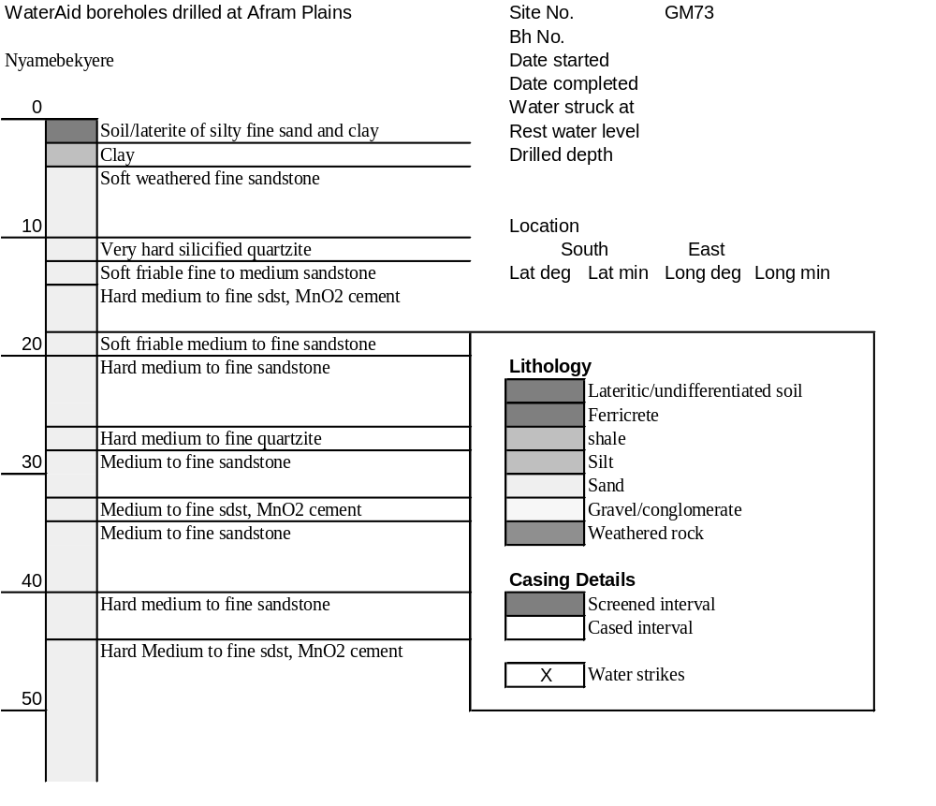Date completed 22/01/2000

Summary Lithological Log
Depth(m)
From To
0 1 Soil/laterite of silty fine sand and clay
1 3 Very weathered medium to fine sandstone and clay
3 4.1 Clay
4.1 10.2 Soft weathered fine sandstone
10.2 11.2 Very hard silicified quartzite
11.2 15.2 Soft friable fine to medium sandstone
15.2 18.3 Hard medium to fine sandstone with manganese cement
18.3 20.3 Soft friable medium to fine sandstone
20.3 26.4 Hard medium to fine sandstone
26.4 28.4 Hard medium to fine quartzite
28.4 31.5 Medium to fine sandstone
31.5 34.5 Medium to fine sandstone with manganese cement
34.5 39.6 Medium to fine sandstone
39.6 43.7 Hard medium to fine sandstone
43.7 44.7 Medium to fine sandstone
44.7 55.9 Hard Medium to fine sandstone with manganese cement

Detailed Lithological Log
Depth(m) Lithology
From To

Soil/laterite of silty fine sand and clay
0 1 Light grey very weathered silty fine sand with subordinate light grey
clay and orange partings

Very weathered medium to fine sandstone and clay
1 2 Light grey and pink very weathered sandstone with light grey clay,
orange and black Fe and Mn rich partings
2 3 White to light grey weathered medium to fine grained sandstone, some
purple grains with much white kaolin clay, reduced orange Fe oxide
weathering

Clay
3 4.1 White to yellow and light orange very soft kaolin clay

Soft weathered fine sandstone
4.1 5.1 Dark red to purple, soft, thinly bedded very weathered silty fine
grained sandstone
5.1 6.1 Dark purple fine to medium grained sandstone with pink grains and
black cement
6.1 7.1 Dark red fine grained sandstone with weathered white to light green
partings
7.1 8.1 Dark red/purple friable fine grained sandstone thinly layered with
pink/white intergrain partings
8.1 9.1 Dark purple fine grained sandstone with pink angular weathered grains
9.1 10.2 Dark red fine to medium grained sandstone with pink grains, friable
platy fragments

Very hard silicified quartzite
10.2 11.2 Very hard silicified? black/red fine grained quartzite, some black mica
or cryptocrystalline manganese oxide

Soft friable fine to medium sandstone
11.2 12.2 Fairly soft dark red and black fine to medium sandstone with pink
grains
12.2 13.2 Interbedded light red grey hard and dark red and black soft friable
medium to fine grained sandstones with some mica
13.2 14.2 Dark purple/red friable fine to medium sandstone with some white clay
matrix and some mica
14.2 15.2 Dark red/black friable medium to fine sandstone weathered with black
manganese along betting planes, very micaceous?

Hard medium to fine sandstone with manganese cement
15.2 16.3 Dark purple/red and black hard micaceous medium to fine grained
sandstone, with soft friable bands and black Mn oxide along bedding
planes
16.3 17.3 Dark purple/red and black fairly hard micaceous medium to fine
grained sandstone, with soft friable bands, odd brown/grey layers and
black Mn oxide along bedding planes
17.3 18.3 Dark purple/red and black hard micaceous medium to fine grained
sandstone, with soft friable bands and black Mn oxide along bedding
planes

Soft friable medium to fine sandstone
18.3 19.3 Dark red/black fairly soft fissile medium to fine weathered sandstone
19.3 20.3 Dark red black weathered and friable, fine to medium grained
sandstone with odd weathered fracture

Hard medium to fine sandstone
20.3 21.3 Red/black hard quartzitic medium to fine sandstone with some grey
green chlorite deposited along fractures
21.3 22.4 Dark red/black hard and soft medium to fine grained sandstones,
quartzitic in part
22.4 23.4 Dark red/black friable micaceous medium to fine grained sandstone
23.4 24.4 Fairly hard dark black/red micaceous medium to fine grained
sandstones with some green grey chloritic fragments
24.4 25.4 Hard black with red medium to fine grained sandstones
25.4 26.4 Hard black to friable dark/red medium to fine grained sandstones

Hard medium to fine quartzite
26.4 27.4 Dark pink grey quartzite with green chloritic deposits along fractures
(Water struck)
27.4 28.4 Hard grey/red medium to fine grained quartzite with green chlorite on
fracture surfaces

Medium to fine sandstone
28.4 29.5 Black medium to fine grained sandstone with red grains and orange
inclusions
29.5 30.5 Pink red and subordinate black medium to fine grained compact
sandstones
30.5 31.5 Hard pink/red and black well cemented medium to fine sandstone

Medium to fine sandstone with manganese cement
31.5 32.5 Dark red medium to fine grained hard sandstone with much black mica
like Mn oxide along bedding planes
32.5 33.5 Dark red/black hard medium to fine grained sandstone with black mica
like Mn oxide along bedding planes
33.5 34.5 Dark red brown and pink medium to fine grained sandstone with black
Mn oxide cement

Medium to fine sandstone
34.5 35.6 Dark red brown hard medium to fine grained sandstone with pink and
black grains
35.6 36.6 Dark brown medium to fine sandstone with pink grains, micaceous in
parts with some orange staining
36.6 37.6 Dark red/brown fissile medium to fine grained sandstone with pink and
black grains and black mica - possibly Mn oxide cement
37.6 38.6 Dark red/brown and black medium to fine grained sandstone with pink
grains and black mica, some red/orange staining and green grey
chlorite
38.6 39.6 Dark red/brown medium to fine grained sandstone with pink and black
grains, some red/brown fragments and green grey chlorite

Hard medium to fine sandstone
39.6 40.6 Hard pink/black sandstone, well indurated
40.6 41.7 Dark red/brown and black medium to fine sandstones
41.7 42.7 Very hard dark brown weathered sandstones with pink and orange
grains, friable in parts
42.7 43.7 Dark red/brown medium to fine friable sandstones with pink grains and
black Mn oxide cement

Medium to fine sandstone
43.7 44.7 Dark red/brown friable medium to fine sandstone with pink and black
rounded grains

Hard Medium to fine sandstone with manganese cement
44.7 48.8 Dark red/brown hard medium to fine grained sandstone with pink
rounded grains and black Mn oxide cement, softer at 44.5m
48.8 49.8 Dark red/brown hard medium to fine sandstone with pink round grains
and black Mn oxide cement, softer at 45.25 and 45.5m
49.8 50.8 Dark red/brown medium to fine sandstone with pink rounded grains,
black Mn oxide cement and mica like Mn oxide along bedding planes,
soft at 46.3 and 46.8m
50.8 51.8 Red brown medium to fine grained sandstone with rounded pink grains
and reduced black Mn oxide cement, softer at 47.35 and 47.6m
51.8 52.8 Hard light grey red to dark red/black medium to fine sandstone with
black Mn oxide cement
52.8 53.8 Light grey red nonweathered and dark red and black weathered
medium to fine sandstone. Black Mn oxide cement in weathered
53.8 54.9 Dark brown/red and light grey/orange medium to fine sandstone, with
black Mn oxide cement in dark brown/red, odd fragment of white fault
quartz in the lighter rock, softer at 50.5m
54.9 55.9 Dark brown medium to fine sandstone with pink grains and black Mn
oxide cement. Odd platy fragment of dark brown micaceous siltstone,
soft at 51.9m

